**MCSNet: Multi-Channel Sharing Network for Single Image Super-Resolution**

**1,2Wazir Muhammad, 1Supavadee Aramvith**

1 “Multimedia Data Analytics and Processing Unit, Department of Electrical Engineering, Faculty of Engineering, Chulalongkorn University, Bangkok 10330, Thailand”.

2Electrical Engineering Department BUET, Khuzdar, Pakistan

Email: [1,2wazir.laghari@gmail.com](mailto:1,2wazir.laghari@gmail.com), [1](mailto:1supavadee.a@chula.ac.th)[supavadee.a@chula.ac.th](mailto:1supavadee.a@chula.ac.th)

**Abstract:** The performance and processing speed of single-image super-resolution (SISR) increased every day due to the rapid advancement in convolutional neural network (CNN) architectures. However, CNN-based architectures have a high computational cost, more processing time, and reconstructed results are still unsatisfactory. Furthermore, CNN architectures depend on the single-channel type network architecture reconstructing the high-resolution (HR) image, which also creates problems during the training, extracted features are not received at the last end layer. To report these problems, we proposed a Multi-Channel Sharing Network for Single Image Super-Resolution (MCSNet). In addition, the multi-channel sharing technique is used to extract and share the feature information through different routes, which is very important to resolve the SISR problem. Extensive quantitative and qualitative experimental results show that our proposed approach achieves a better trade-off against other state-of-the-art methods regarding peak signal-to-noise ratio (PSNR), computational complexity, and processing speed. Especially on challenging enlargement scale factor 8×, our proposed method improves the overall average PSNR on all test datasets, including Manga109, Urban100, Set14, and Set5 by 2.04dB with the baseline method.

***Index******terms:***Single image super-resolution, Dense channel sharing block, LeakyReLU, Convolutional Neural Network.

**INTRODUCTION**

The main target of single image super-resolution (SISR) is to reconstruct the high quality / high-resolution (HR) output image from its degraded low-quality / low-resolution (LR) input image [1-6]. The SISR is still a challenging task to solve due to its ill-posed problem. Various image super-resolution (SR) methods have been developed to report such issues, including bicubic interpolations, reconstruction, and learning-based approaches. Deep CNN learning-based image SR methods have recently achieved tremendous performance due to the rapid improvement in the convolutional neural network (CNN) design. Recently, available approaches to deep learning-based CNN methods. Among them, Dong et al. [7] initially proposed the shallow-based architecture using three CNN layers to develop the direct relationships between an original LR input image and a high-resolution reconstructed output image known as a super-resolution convolutional neural network  (SRCNN). These three layers perform three basic operations: feature extraction, extraction, non-linear mapping, and restoration. This approach’s main flaws are using the bicubic interpolation as a pre-processing step to upscale the LR image as an input and reconstruct the interpolated version of an HR output image. The author of SRCNN [7] modified the architecture and replaced the pre-upsampling bicubic interpolation technique with a post-upsampling learnable layer (transpose convolution) named Fast SR Convolutional Neural Network (FSRCNN) [8]. This modification leads to a decrease in the number of parameters and memory consumption. To improve the shortcomings observed during the SRCNN [7] and FSRCNN [8] models, Kim et al. used the concept of the Visual Geometry Group (VGG) model, which is used in the ImageNet classification task. They proposed the 20-layer network known as Very Deep Super Resolution (VDSR) [9]. The performance of VDSR [9] is better than earlier approaches such as SRCNN [7] and FSRCNN [8] with large margin gap. Furthermore, VDSR [9] employed the residual learning technique to avoid the vanishing gradient problem and increase convergence speed. The relationship between SRCNN [7] and the sparse-SCN methods confirms its acceptable performance. Wang et al. [10] replaced mapping layers with the set of sparse-based coding type networks, commonly known as SCN (sparse coding network). The deeper is the better to follow this concept. Kim et al., [11] proposed the image SR method using a deeply recursive CN (DRCN). This architecture used a very deep recursive type layers (16 times recursions). DRCNN [11] method same convolutional layers repeatedly apply several times as desired, but the computational cost does not increase although more times recursions are used.

Likewise, Tai et al. suggested the concept of a two-way novel network, one for a deep recursive residual network (DRRN) [12], and the next is used for a persistent memory network (MemNet) [13]. The earlier designed is employed for the recursive type of learning to reduce the number of parameters. The final part of a model resolves the long-term dependency problem. However, these two methods used more processing time and extra huge memory consumption in the testing and the training process. A 27-CNN layer with robust Charbonnier loss function network architecture proposed by Lai et al. presented the Laplacian pyramid SR network (LapSRN) [14] to reconstruct the HR images gradually.

Recently, deep CNN-based single image SR [15, 16] is to attain the improved performance compared to conventional methods, but still faces some challenging issues [17]. Generally, the deep CNN model used a convolutional layer side-by-side to design a deeper framework, but introducing the vanishing gradient problem and later end layers work as a dead layer. Similarly, some well-known deep CNN methods [7, 9] used the interpolation technique as a pre-processing stage to upscale the LR image and then extracted the CNN features from the upscaled version of the HR image. These approaches are unsuccessful because they introduce the new noise in the models and use more burden on the model during the training. Additionally, deep CNN relies on two-way multi-scale channel sharing type network architecture, which does not extract the complete feature information through the previous layers. To address these problems, we have suggested the Multi-Channel Sharing Network for Single Image Super-Resolution, named MCSNet, which use the Dense channel sharing ResNet blocks (DCSRB) with local as well as global skip connections. In summary, we establish a novel Multi-Channel Sharing Network for Single Image Super-Resolution, which improves PSNR/SSIM, and perceptual quality of the LR image.

The overall main contribution of our MCSNet method can be summarized as follow:

• Inspired by Multi-scale Channel Sharing with ResNet architecture, we proposed a Multi-Channel Sharing Network for Single Image Super-Resolution method with post-upsampling technique to reconstruct the high-quality HR output image.

• We proposed a new multi-channel path scheme to boost the representations of features of the HR image excellently. Multi-channel path scheme consists of dense channel sharing ResNet block (DCSRB), which facilitates the feature extraction through each earlier and subsequent CNN layer.

• Conventional deep CNN methods used Rectified Linear Unit (ReLU) activation function, which introduces the vanishing-gradient problems in training, in case of deeper network architecture. In this regard, we changed the ReLU with leaky ReLU activation function to avoid the vanishing-gradient problems and perform the model’s training more efficiently.

The remaining parts of the paper are divided as follows: the proposed method is presented in Section II. The experimental calculations are discussed in Section III. Finally, the conclusion is reported in the last section.

1. **PROPOSED METHOD**

In this paper, we propose the Multi-Channel Sharing Network for Single Image Super-Resolution with the support of dense channel sharing Resnet block (DCSRB). First, we discuss the proposed network architecture of MCSNet in detail, and then we discuss the DCSRB block with different CNN layers used in the main architecture, as shown in Figure 1. The proposed network framework of MCSNet used two CNN layers followed by Leaky Rectified Linear Unit (LeakyReLU) activation function. These CNN layers extracted the initial features and then fed the four DCSRB blocks side-by-side and timely updated features information received through local and global skip connections. Finally, the cumulative LR features pass through the deconvolution layer to upscale and reconstruct the HR output image. The design of LReLU depends on the ReLU, and it provides two outputs, one for (0, x) and the other for (x,0). Additionally, the earlier approach depends on a maximum of two-channel sharing residual blocks to extract the image features of different scales [18]. The reconstructed features information is satisfactory, but the information is lost in the case of deeper and denser network architecture. It cannot extract the detailed features, and sometimes information is stuck. In our proposed DCSRB block design in such a way to split the original features information with five different kernel size multi-scale channels in the order of 1×1, 3×3, 5×5, 7×7, and 9×9. The first branch used 1×1, convolutional neural network layers to reduce the dimension of the input data and the computational cost of the model [19]. The other branches of different kernel size are used to extract the multi-channel information as shown in Figure 2. Finally, in the reconstruction phase, an upsampling operation is used by 3×3 deconvolution to generate the high-quality or high-resolution (HR) output image. The 1×1 convolution operation is used before the deconvolution layer to reduce the size of the dimension.

1. **EXPERIMENTS**

The experimental section explains, the training and testing datasets strategy for reconstructing the HR image. Our MCSNet used the three different training datasets, such as Yang et al., [20], BSDS100 [21] and DIV2K [22] (including 50 images) for training purposes. The complete training dataset is split into two sections, like 80% for training and 20% for validation. Our proposed method is tested on four standard publicly available datasets, including Set5 [23], Set14 [20], Urban100 [24], and Manga109 [25]. Set5 [23], and Set14 [20] used the images in the order of 5 and 14. In Urban100 and Manga109 [25] available images are in the order of 100 and 109. We evaluated our model with frequently used quality metrics is, the PSNR/SSIM, because these metrics directly related to pixel values. Our model performs training and testing under the Windows 10 operating system environment with the NVIDIA GeForce RTX20270 GPU model having 16 GB RAM. Training performs on an enlargement factor 8x in Keras 2.15 and MATLAB2018 a framework. The quantitative experimental results are present in Table 1, which shows that the proposed method attains higher average quantitative values. Additionally, we evaluate the performance of our proposed method in terms of perceptual quality with different publicly available methods, as shown in Figure 3. The proposed method with other’s as shown in Figure 3 used three images of butterfly, zebra, and PrayerHaNemurenai obtained from Set5, Set14, and Manga109 with scale factor 8×. In the case of the bicubic interpolation technique, the texture generated is blurry output. Other methods such as SRCNN, VDSR, and DRCN produce improved results than the baseline method. In our proposed method, the reconstructed output is a visually pleasing texture detail with ahigh value of PSNR/SSIM.

# **CONCLUSION**

In this paper, we proposed a Multi-Channel Sharing Network for Single Image Super-Resolution (MCSNet) based on the convolution, LeakyReLU, and dense channel sharing Resnet block (DCSRB) for reconstructing the visually pleasing HR output image. To increase the quantitative and qualitative evaluation of the LR image, we employed the four DCSRB bocks followed by the LeakyReLU activation function. Furthermore, to increase the training convergence process and fix the dying ReLU problem in the dense CNN model, we replaced the ReLU activation function with LeakyReLU non-linear activation function. Moreover, the whole network architecture adopts local and global skip connections to capture the high-frequency feature information for single image super-resolution reconstruction. Quantitative and qualitative performance evaluated on four benchmark test datasets demonstrates that the proposed MCSNet can provide superior performance in terms of reconstructed results.

**ACKNOWLEDGEMENTS**

“This work is supported by the Second Century Fund (C2F) Chulalongkorn University Bangkok Thailand, Electrical Engineering Department Chulalongkorn University Bangkok, Thailand, Thailand Science research and Innovation Fund Chulalongkorn University (CU_FRB65_ind (9)_157_21_23), Ratchadaphiseksomphot Endowment Fund (Multimedia Data Analytics and Processing Research Unit), and Thailand Science research and Innovation Fund Chulalongkorn University CU_FRB65_soc-(1)_001_27_01”.

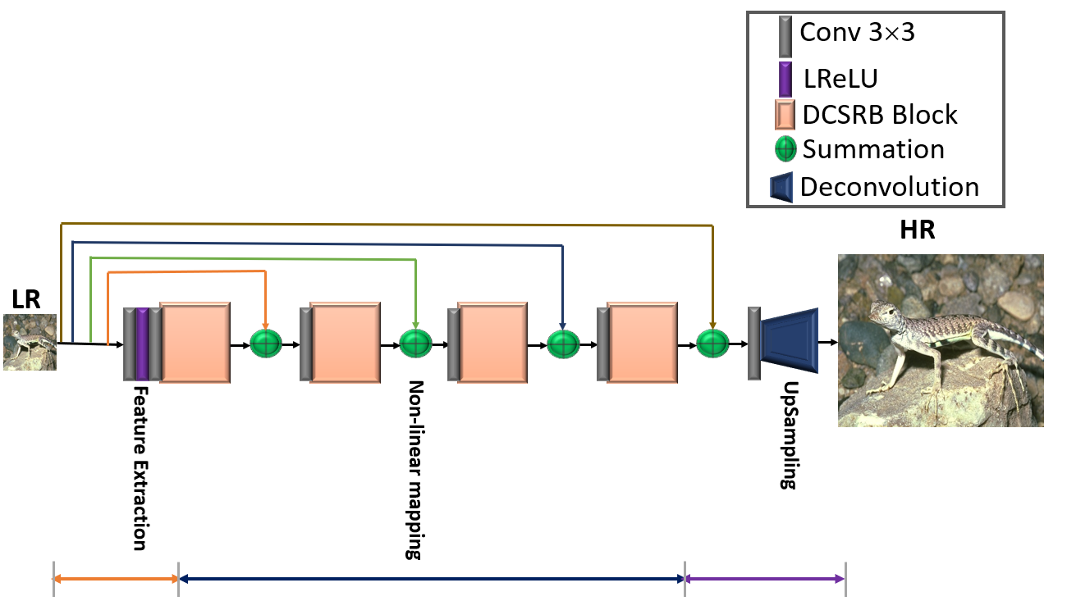

**Figure 1: Proposed Multi-Channel Sharing Network for Single Image Super-Resolution (MCSNet)**

**Figure 2: Dense channel sharing ResNet Block (DCSRB)**

Table 1

The quantitative comparison of average PSNR/SSIM with existing image super-resolution algorithms on four test datasets (Set5, Set14, Urban100, and Manga109) on challenging enlargement factor ×8.

|  |  |  |  |  |  |  |  |  |
| --- | --- | --- | --- | --- | --- | --- | --- | --- |
| Datasets | Scale | Bicubic  PSNR  SSIM | SRCNN [7]  PSNR  SSIM | FSRCNN [8]  PSNR  SSIM | SCN [10]  PSNR  SSIM | VDSR [9]  PSNR  SSIM | DRCN [11]  PSNR  SSIM | MCSNet  PSNR  SSIM |
| SET5 [23] | ×8 | 24.40 0.6580 | 25.33 0.6900 | 20.13  0.5520 | 25.59 0.7071 | 25.93 0.7240 | 25.93  0.7230 | 25.95  0.7231 |
| SET14 [20] | ×8 | 23.10 0.5660 | 23.76 0.5910 | 19.75  0.4820 | 24.02 0.6028 | 24.26 0.6140 | 24.25  0.6141 | 25.12  0.6152 |
| URBAN100 [24] | ×8 | 20.74 0.5160 | 21.29 0.5440 | 21.32  0.5380 | 21.52 0.5571 | 21.70 0.5710 | 21.71  0.5710 | 23.38  0.5821 |
| MANGA109 [25] | ×8 | 21.47 0.6500 | 22.46 0.6950 | 22.39  0.6730 | 22.68 0.6963 | 23.16 0.7250 | 23.20  0.7240 | 23.43  0.7331 |
| Average | ×8 | 22.43  0.5975 | 23.21  0.6300 | 20.90  0.5613 | 23.45  0.6408 | 23.76  0.6585 | 23.77  0.6580 | **24.47**  **0.6634** |

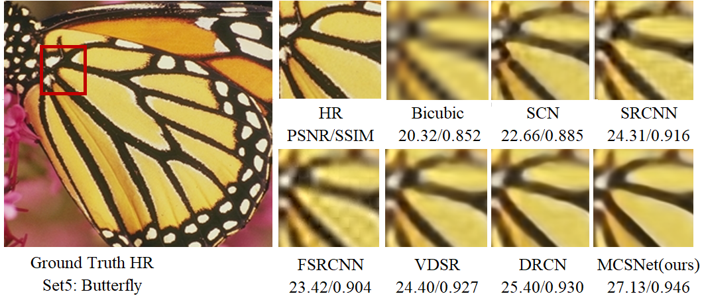

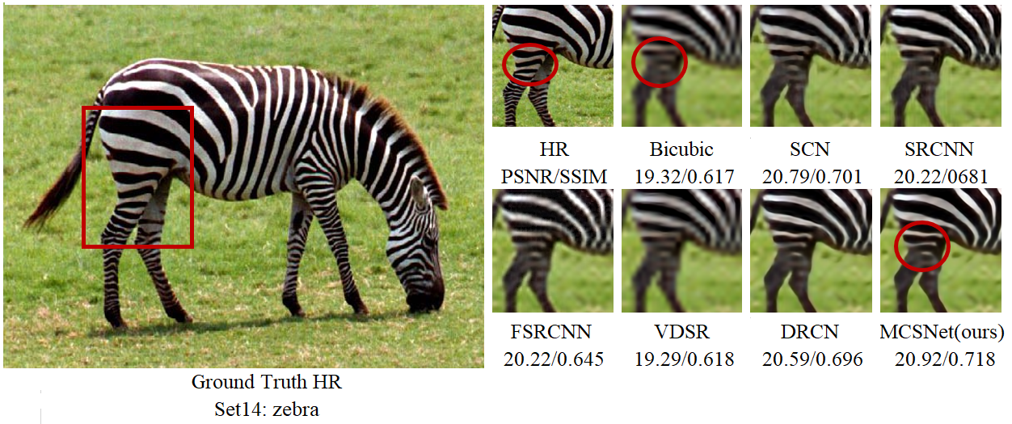

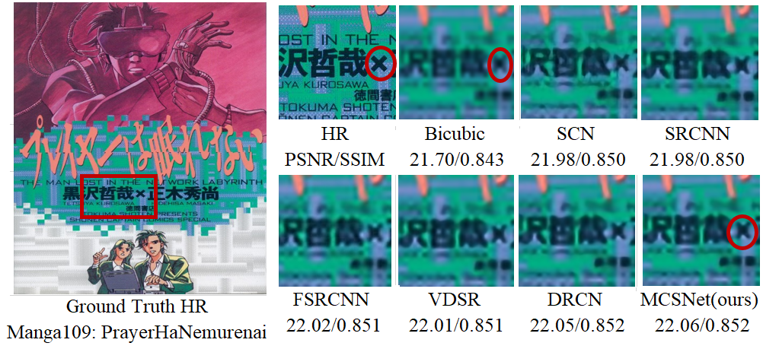

**Figure 3: Presents the perceptual quality comparison on enlargement factor 8× of different image super-resolution methods using test datasets of Set5, Set14 and Manga109.**

**REFERENCES**

1. Freeman, W.T., E.C. Pasztor, and O.T. Carmichael, *Learning low-level vision.* International journal of computer vision, 2000. **40**(1): p. 25-47.

2. Luo, J., et al., *Multi-scale receptive field fusion network for lightweight image super-resolution.* Neurocomputing, 2022. **493**: p. 314-326.

3. Zhang, X., et al., *Remote Sensing Image Super-Resolution via Dual-Resolution Network Based on Connected Attention Mechanism.* IEEE Transactions on Geoscience and Remote Sensing, 2021. **60**: p. 1-13.

4. Yang, X., et al., *Remote sensing image super‐resolution based on convolutional blind denoising adaptive dense connection.* IET Image Processing, 2021. **15**(11): p. 2508-2520.

5. Qin, D. and X. Gu, *Single-image super-resolution with multilevel residual attention network.* Neural Computing and Applications, 2020. **32**(19): p. 15615-15628.

6. Jiang, J., H.M. Kasem, and K.-W. Hung, *A very deep spatial transformer towards robust single image super-resolution.* IEEE Access, 2019. **7**: p. 45618-45631.

7. Dong, C., et al., *Image super-resolution using deep convolutional networks.* IEEE transactions on pattern analysis and machine intelligence, 2015. **38**(2): p. 295-307.

8. Dong, C., C.C. Loy, and X. Tang. *Accelerating the super-resolution convolutional neural network*. in *European conference on computer vision*. 2016. Springer.

9. Kim, J., J.K. Lee, and K.M. Lee. *Accurate image super-resolution using very deep convolutional networks*. in *Proceedings of the IEEE conference on computer vision and pattern recognition*. 2016.

10. Wang, Z., et al. *Deep networks for image super-resolution with sparse prior*. in *Proceedings of the IEEE international conference on computer vision*. 2015.

11. Kim, J., J.K. Lee, and K.M. Lee. *Deeply-recursive convolutional network for image super-resolution*. in *Proceedings of the IEEE conference on computer vision and pattern recognition*. 2016.

12. Tai, Y., J. Yang, and X. Liu. *Image super-resolution via deep recursive residual network*. in *Proceedings of the IEEE conference on computer vision and pattern recognition*. 2017.

13. Tai, Y., et al. *Memnet: A persistent memory network for image restoration*. in *Proceedings of the IEEE international conference on computer vision*. 2017.

14. Lai, W.-S., et al. *Deep laplacian pyramid networks for fast and accurate super-resolution*. in *Proceedings of the IEEE conference on computer vision and pattern recognition*. 2017.

15. Muhammad, W., S. Aramvith, and T. Onoye, *Multi-scale Xception based depthwise separable convolution for single image super-resolution.* Plos one, 2021. **16**(8): p. e0249278.

16. Muhammad, W. and S. Aramvith, *Multi-scale inception based super-resolution using deep learning approach.* Electronics, 2019. **8**(8): p. 892.

17. Cai, Y., et al., *Image Reconstruction of Multibranch Feature Multiplexing Fusion Network with Mixed Multilayer Attention.* Remote Sensing, 2022. **14**(9): p. 2029.

18. Li, J., et al. *Multi-scale Residual Network for Image Super-Resolution*. in *Computer Vision – ECCV 2018*. 2018. Cham: Springer International Publishing.

19. Lan, R., et al., *MADNet: a fast and lightweight network for single-image super resolution.* IEEE transactions on cybernetics, 2020. **51**(3): p. 1443-1453.

20. Yang, J., et al., *Image super-resolution via sparse representation.* IEEE transactions on image processing, 2010. **19**(11): p. 2861-2873.

21. Arbelaez, P., et al., *Contour detection and hierarchical image segmentation.* IEEE transactions on pattern analysis and machine intelligence, 2010. **33**(5): p. 898-916.

22. Agustsson, E. and R. Timofte. *Ntire 2017 challenge on single image super-resolution: Dataset and study*. in *Proceedings of the IEEE conference on computer vision and pattern recognition workshops*. 2017.

23. Bevilacqua, M., et al., *Low-complexity single-image super-resolution based on nonnegative neighbor embedding.* 2012.

24. Huang, J.-B., A. Singh, and N. Ahuja. *Single image super-resolution from transformed self-exemplars*. in *Proceedings of the IEEE conference on computer vision and pattern recognition*. 2015.

25. Matsui, Y., et al., *Sketch-based manga retrieval using manga109 dataset.* Multimedia Tools and Applications, 2017. **76**(20): p. 21811-21838.